National Achievement Survey – Class VII
தேசிய அடைவு ஆய்வு – வகுப்பு VII
Mathematics
1. | Length and breadth of a field are 200m and 100m. The number of sapplings planted at 10m gap inside the field with a distance of 10m from the boundaries are
 | 1. | 200
 | 2. | 148
 | 3. | 144
 | 4. | 140
2. | In a village, there are 45% of men, 35% of women and 20% of children. If the number of children are 560, then how many men are more than women in that village.
 | 1. | 280
 | 2. | 980
 | 3. | 1260
 | 4. | 700
3. | Among 100 fruits purchased by Kandhan, there are 8 apples more than oranges and 9 pomegranates more than apples. The number of pomegranates, apples and oranges are
 | 1. | 25, 33, 42
 | 2. | 42, 33, 25
 | 3. | 33, 25, 42
 | 4. | 25, 42, 33
4. | In a triangle, the second angle is 45⁰ more than twice the first angle. The third angle is 15⁰ less than thrice the first angle. Then the second angle is
 | 1. | 25⁰
 | 2. | 60⁰
 | 3. | 80⁰
 | 4. | 95⁰
5. | The average of 154, 145, Y, Y+4, 160, 151, 149, 149, 150, 144 is 151, then the value of Y is ______________.
 | 1. | 150
 | 2. | 304
 | 3. | 152
 | 4. | 1202
6. | Addition of -24pq, 10pq, -7pq and 30pq is
 | 1. | 23pq
 | 2. | 71pq
 | 3. | -71pq
 | 4. | 9pq
7. | The Value of $\left(\frac{3^{7}}{3^{4}}\right) × \left(3^{5}×3^{6}\right)÷{(3^{2})}^{5}$ is
 | 1. | 3²⁴
 | 2. | 3⁴
 | 3. | 3²
 | 4. | 3⁻⁴
8. | If Rs.5000 becomes Rs.7000 in 8 years, then the rate of interest is
 | 1. | 35%
 | 2. | 8%
 | 3. | 12%
 | 4. | 5%
9. | 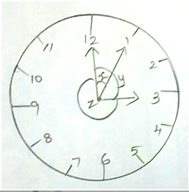 |  | Find the types of angle x, y and z from the given figure.
 | 1. | acute, right, obtuse
 | 2. | acute, acute, right
 | 3. | right, right, obtuse
 | 4. | acute, acute, obtuse
10. | In a school, 11th standard students admission are given here.  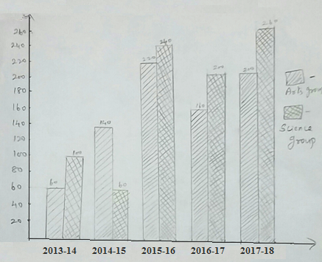  In which two years, the difference between arts group and science group are the same?
 | 1. | 2013-14, 2014-15
 | 2. | 2013-14, 2015-16
 | 3. | 2013-14, 2016-17
 | 4. | 2014-15, 2017-18
Scoring key

Q.No | Answer |  | Q.No | Answer
1 | 3 |  | 6 | 4
2 | 1 |  | 7 | 2
3 | 2 |  | 8 | 4
4 | 4 |  | 9 | 1
5 | 3 |  | 10 | 3

Mathematics (Learning Outcome) Class VII
Q.  No. | L.O.  No. | Learning Outcome
1. | 718 | Calculates areas of the regions enclosed in a rectangle and a square.
2. | 710 | Solves problems related to conversion of percentage to fraction and decimal and vice versa.
3. | 707 | Represents daily life situations in the form of a simple equation and solves it.
4. | 714 | Finds unknown angle of a triangle when its two angles are known.
5. | 719 | Finds various representative values for simple data from her / his daily life contexts like mean, median and mode.
6. | 708 | Adds / subtracts algebraic expressions.
7. | 706 | Uses exponential form of numbers to simplify problems involving multiplication and division of large numbers.
8. | 712 | Calculate profit / loss percent and rate percent in simple interest.
9. | 713 | Classifies pairs of angles based on their properties as linear, supplementary, complementary adjacent and vertically opposite and finds value of the one when the other is given.
10. | 721 | Interprets data using bar graph such as consumption of electricity is more in winters than summer, runs scored by a team in first 10 overs etc.,

